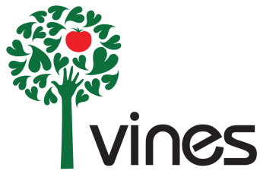
VINES INTERNSHIPS - Apply by March 19th
Binghamton Urban Farm (BUF) Assistant Manager Internship
Summer 2015
Description: The BUF assistant manager will assist in the planning and implementation of the BUF growing season. Responsibilities include general garden and orchard care, working with community members and community partner organizations, and working with other VINES staff to ensure a successful growing season. The BUF assistant manager will also work with the VINES summer youth program, a six week long program that hires City of Binghamton youth to work at the urban farm and learn about urban agriculture and food security. The assistant manager intern will learn how to plan and implement a growing season for a market garden that includes soil fertility management, crop planning, and a diversity of agricultural techniques. Assistant manager will also learn about the internal workings of a not-for-profit organization by attending board meetings, staff meetings and participating in other organizational activities. Assistant manager will work directly with and report to the BUF manager. Email cover letter and resume to sean@vinesgardens.org by March 15th to apply.
Farm Share Food Systems Internship
Summer 2015, Fall 2105
Description: This Internship focuses on Binghamton Farm Share, a VINES program that connects residents of all income levels to fresh produce from local farmers. It involves direct service in the community addressing food justice, agriculture, and community engagement. Main responsibilities include interacting with community members to distribute local produce at the same time and place each week, providing support and education to participants, processing payment including EBT (food stamp) transactions, and tracking customers. Other duties include creating recipes, recruiting members, and helping organize events. This internship is ideal for motivated individuals passionate about issues surrounding hunger and food insecurity in the Binghamton community, who are looking for experience with non-profit organizations. Interns must be available Fridays evenings and/or Monday, Tuesday mornings to be considered. Email cover letter and resume to natalie@vinesgardens.org by March 15th to apply.

